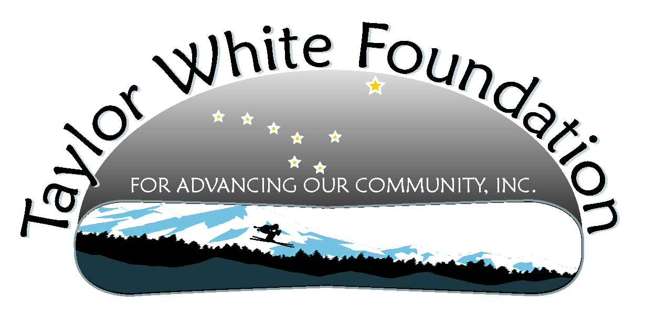
Strategic Planning Minutes
September 18, 2011
The board agreed the vision was still compelling and reflected current thought and will remain as:
In a desire for Taylor's death to be a force for good, The Taylor White Foundation will work toward building a community environment that better supports Juneau teens in healthy choices around high risk behaviors (including drugs and alcohol).
When asked the question, “If this vision came true what would be different about Juneau? “, board responses were:
  - There would be a social gathering places for 16-21
  - Transportation 24/7 reasonably priced could get a ride when you didn’t want to or it wasn’t safe
  - Communication wherever there is a road system – (call box?)
  - Bunk house out the road
  - Have a way to keep community awareness and memory of accidents and other tragic accidents active
  - Every kid would have some exposure to discussion with peers that walked them through tough decision/realities around high risk behavior and made it real for them –
    - There would be a decision “protocol” or tree to help kids have this decision vocabulary
  - There would be out the road monitoring on a regular basis by police department/troopers
  - Parents would model the healthy behavior
  - There would be community forums to talk about truth of alcohol/drug use
  - We would have some measurement and feedback as to changes in any of the above conditions as well as to behavior listed below
When asked the question, “How would teen behaviors/activities look different? “, board responses were:
- Culture of peer pressure to not drive drunk
- Culture to call for a driver when drinking
- Culture could support it is “cool” to not do high risk behavior – wrist bands and sweatshirts make a difference (requires continual effort)
- Culture to call for a driver when drinking
- At football games at FD kids wouldn’t be drinking, drugging, stealing/vandalizing and having sex

How would the vision be reflected in high school?
- By making the truth of what can happen a reality for all kids and posters, communication, programs reinforce the fact
- With curriculum built in that includes how to have respectful communication with peers and adults about hard topics and conversations
How would the vision be reflected in middle school?
- Impacting middle school kids would best be done by taking it out of school to kids and parents. This way you can tackle topics that wouldn’t be allowed in the school. The challenge is how to attract those that really need it. Hosting community forums came up as a vehicle for this.
- Build foundation through interactive, not just facts, reality based, testimonial that help you see why, acknowledge that it has something attractive
The mission for the Foundation, which are the primary goal areas going forward were determined to be:
- Change the culture amongst teens about the acceptability of high risk behaviors
- Develop activities and outlets for teenagers that are engaging, exciting, and challenging with acceptable risk.
- Support environmental factors that provide a safety net for kids who have made high risk choices
Projects for 2012 (each will have a tactical plan to outline steps to implement and complete)
- Develop a project plan for Under 21 Club
- Develop a plan of collaboration with high schools and middle schools for meaningful communication and awareness around high risk choices
  - Include supporting schools with incentives for visibility and constant reminders
Projects continued from 2011 (each will have a tactical plan to outline steps to implement and complete)
- Display/Documentary tour of Southeast Alaska
- Updating One Mic Tay instrumental in documentary so TW Foundation owns all rights and the documentary can be downloaded
- Support wider distribution of the documentary statewide and perhaps nationally

